Introduction

This sample demonstrates the using DYMO 7 SDK from JavaScript. This assumes that you have purchased any of DYMO Label printers and successfully installed DYMO DLS software on your computer. The sample allows you to select text on any web page in Internet Explorer and send this selection to the DYMO Printer.

Requirements

First you need the DYMO DLS software installed locally. It contains all required in the sample COM components.

This sample works with Microsoft Internet Explorer only. The sample uses Microsoft’s technique to customize the standard Internet Explorer’s context menu. See the article bellow for the detailed information.

http://support.microsoft.com/kb/177241#appliesto

Making it works

The actual working code is in two HTM files:
- miecontext.htm – starting point of interaction between Internet Explorer and DLS SDK
- ieprintlabels.htm – html page, where you select available DYMO printers and a set of JavaScript functions interaction with SDK.

To start this sample you need to add into registry one entry to link the Internet Explorer context menu with the miecontext.htm file which executes JavaScript.

You can find the entry you need to add in the file miecontext.reg. If you installed SDK samples into default location – just click on this file to merge the content into your registry. Otherwise edit this file with correct location of miecontext.htm file (full path is required). See the reference http://support.microsoft.com/kb/177241#appliesto for detailed information.

Since you added the required key into registry, open the Internet Explorer, select any text on any web page, right-click on selected to bring up the context menu. Click on “DYMO” menu item to execute the script. A new Internet Explorer window titled “DYMO SDK Sample Page” should appear. Most likely you will see the following security notification after page is loaded into your browser (see screenshot below).

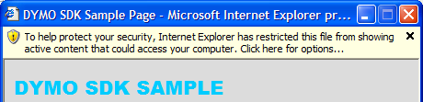

Right-click on the warning and select “Allow blocked content…” Next confirm the selection clicking “Yes” when the following dialog will appear.

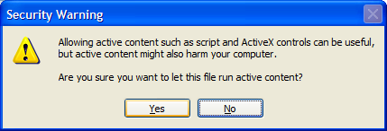

Now you will see the list of available DYMO Label printers on your computer – the whole list of DYMO labels and the text you selected. Clicking print will send the text to the printer.

